|  |  |
| --- | --- |
| **Ex. No. 1** | **Design Web Page using HTML** |
| **Date of Exercise** | 12/12/2022 |
| **Github Link** | <https://github.com/Hemanthkumar01machine/Web_Technologies_20CS2056L> |

**Aim**

To create a HTML webpage for my personal profile with the given elements.

**Description**

HTML is a standard Markus Language that is designed for webpages is displayed by the browsers. The following are the some of the tags in html.

* <!DOCTYPE html>⇒ Not a tag but notifies that it is a html file to the browsers.
* html => Root element of a html web page, all the tags will be placed inside to it.
* head => Holds the title, metadata, stylesheets script linking to the webpage. body This contains all the contents of the document that is displayed in the webpage.
* center => Used to align the text to the center
* hi-h6→ Defines the headings his most important heading, his least important &
* table => To define the table
  + Sub elements: th: heading to the column for defines a now to holds the data in each cell
  + Attributes: border to set the width of the border. » align to align the contents width → for setting the width of the cell
* img => To embed an image to the webpage.
  + Attributes: src: where location is provided alt + Alternative text, if image is not displayed
* hr => thematic break in the web page. horizontal rule is also displayed.
* a => for creating a hyperlink to other
  + attributes: href: location of the other / url
* p => n defines a paragraph; single blank line is given before each by the browser.
* ol => defines an ordered list [ Numerical/Alphabetical "attribute li each element in the list item ul => defines unordered list [bulleted] attribute. 11
* b => makes the text content bold.
* strong => b+ with strong importance.

**Program**

<!DOCTYPE html>

<html lang="en">

<head>

<meta charset="UTF-8">

<meta http-equiv="X-UA-Compatible" content="IE=edge">

<meta name="viewport" content="width=device-width, initial-scale=1.0">

<title>HEMANTHKUMAR P B_resume</title>

</head>

</html>

<body>

<center>

<h3>My Resume Page</h3>

</center>

<table border="0">

<tr>

<td width="30%" align="left">

<strong>HEMANTHKUMAR P B<br>

9/1, 5/1, Rajavathani Street, Shevapet,<br>

Salem, Tamilnadu-636002<br>

Email: hemanthkumarp@karunya.edu.in<br>

Mobile: +91 6374443482</strong>

</td>

<td width="70%" align="right">

<img src="photo.jpg" alt="HEMANTHKUMAR P B_photo.jpg" height="180">

</td>

</tr>

</table>

<hr>

<table border="0">

<tr align="center">

<td><a href="my_resume.html">My Portfolio</a></td>

<td><a href="https://karunya.edu">My University</a></td>

<td><a href="mailto:hemanthkumarp@karunya.edu.in">For Email</a></td>

<td><a href="tel:6374443482">For Mobile</a></td>

<td>

<a href="https://www.facebook.com/"><img src="1.jpg" width="50" height="50" title="1.jpg"></a>

</td>

<td>

<a href="https://www.linkedin.com/"><img src="2.jpg" width="50" height="50" title="2.jpg"></a>

</td>

<td>

<a href="https://www.instagram.com/"><img src="3.jpg" width="50" height="50" title="3.jpg"></a>

</td>

</tr>

</table>

<hr>

<h4 id="carrer_objective_tagger">Career Objective</h4>

<p>I am familiar with Python programming and want to explore more in the areas of computer hardware and Django. I am dedicated and a fast learner. I wish to learn new things and explore more possibilities using Python. I want to implement and create

new projects in the field of Python Programming.</p>

<hr>

<h4 id="technical_skills_tagger">Technical Skills</h4>

<ol>

<li>Python Programming</li>

<li>Java Programming</li>

<li>C Programming</li>

<li>Computer Architecture</li>

<li>Data Structure</li>

<li>Operating System</li>

<li>Full Stack Development</li>

</ol>

<hr>

<h4 id="education_tagger">Education</h4>

<table border="1">

<tr>

<th>Education</th>

<th>School/College</th>

<th>Board/University</th>

<th>Percentage of Marks</th>

<th>Year of Passing</th>

</tr>

<tr>

<td>B.Tech</td>

<td>Karunya INstitute of Technology and Sciences</td>

<td>Karunya Deemed-to-be University</td>

<td>94.2</td>

<td>2024</td>

</tr>

<tr>

<td>HSC</td>

<td>Holy Cross Matric. Hr. Sec. School</td>

<td>Tamilnadu State Board</td>

<td>81.3</td>

<td>2020</td>

</tr>

<tr>

<td>SSLC</td>

<td>Sri Saradha Balamandir Boys' Matric. Hr. Sec. School</td>

<td>Tamilnadu State Board</td>

<td>91.6</td>

<td>2018</td>

</tr>

</table>

<hr>

<h4 id="advanced_technology_skills_tagger">Advanced Technology Skills</h4>

<ul>

<li>Data Science</li>

<li>Data Visualization</li>

<li>Machine Learning Techniques</li>

</ul>

<hr>

<h4 id="experience_tagger">Experience</h4>

<p><b>Web Development Remote Internship</b><br><br> Taibah University<br> 06/2022 - 07/2022<br> Web development Remote Internship, Covered different life cycle of a programmer, on SRS document and on Web development(Front End: HTML and CSS, Backend:

PHP and JavaScript)</p>

<p><b>Python Programming Internship</b><br><br> Cisco Networking Academy<br> 04/2022 - 06/2022<br> Virtual Internship Program in the Field of Python Programming, The internship had a short course on Python, Assignment problems and ended with a final

project.

</p>

<hr>

<h4>Photo Gallery</h4>

<table>

<tr>

<td width="20%"><img src="image_1.jpg" alt="image_1.jpg" width="250"></td>

<td width="20%"><img src="image_2.jpg" alt="image_1.jpg" width="250" height="150"></td>

<td width="20%"><img src="image_3.jpg" alt="image_1.jpg" width="250"></td>

</tr>

</table>

<hr>

<table>

<tr>

<td><a href="#carrer_objective_tagger">Career Objective</a></td>

<td><a href="#technical_skills_tagger">Technical Skills</a></td>

<td><a href="#education_tagger">Education</a></td>

<td><a href="#advanced_technology_skills_tagger">Advanced Technology Skills</a></td>

<td><a href="#experience_tagger">Experience</a></td>

</tr>

</table>

<hr>

</body>

</html>

**Output**

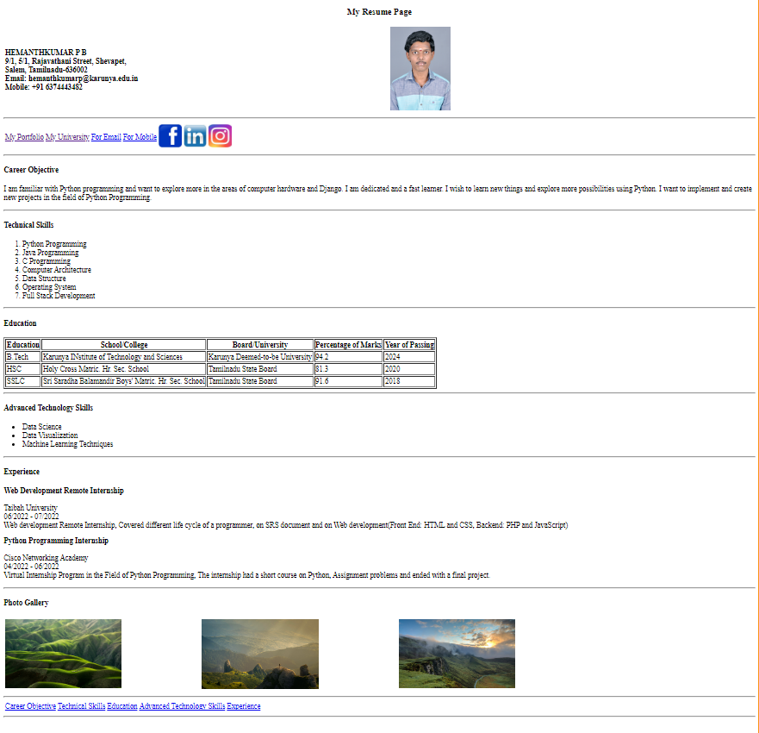

**Result**

The HTML webpage for my personal profile with the given elements has been completed successfully and the webpage is rendered displayed by the browser.